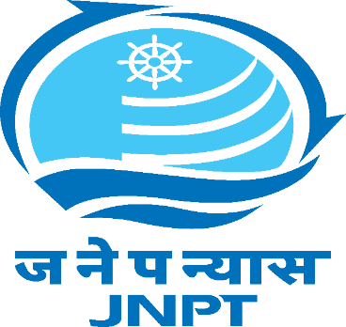

ESSENTIAL SERVICE DUTY PASS

As per the directives received from the Ministry of Home Affairs, Govt. of India. O.M.F.No.40-3/2020-DM-I (A) dated 24.03.2020, for all port related activities including of movement of vehicle and manpower have been declared as the essential services. In order to ensure timely movement of cargo from Warehouse/ CFS to JN Port, Navi-Mumbai, the following person has been permitted by the competent authority, Jawaharlal Nehru Port Trust, Navi-Mumbai to operate the essential services during lockdown period.

Name: __________________________________________________
[PHOTO]
Agency Name & Address: ___________________________________
________________________________________________________
________________________________________________________
Staff No.:
Mobile No.
PANCARD / AADHAR / ANY GOVT. ID No.: ______________________

In case of any difficulties, help line has been created with a dedicated phone no. 022 27244022/ 67814022 and Email ID controlroom@jnport.gov.in, Jawaharlal Nehru Port Trust, Navi-Mumbai.

Disclaimer:

- This pass is issued for performing JN Port related services like Shipping Line, CFS, CHA, Private Container Train Operator, Truck Transporter, Empty Container Yard Operator, Partner Government Agencies, BPCL Liquid Cargo Jetty, Tanks Farms etc. only and not for any other purpose.
- In case this pass is misused concerned company / person shall be solely responsible under Indian Laws

